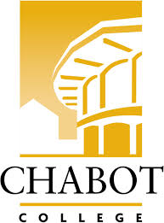
Career Education (CE Committee)
Chabot College – Zoom
Monday, December 9, 2024
12:00-1:00

AGENDA

- Welcome & Land acknowledgement - Terra
- SOAR Day – Heather (10 min)
- CE Open House – Robin & Yvonne
- CE - Student Success Stories - Robin
- Good of the Order - Kristina
- Next Meeting 2/10/2025
- Adjournment

Mission Statement
Chabot College is a dynamic, student-centered community college that serves the educational, career, job skill, and personal development needs of our community. We provide culturally responsive, revitalizing, and sustaining learning and support services driven by a goal of equity. Building upon students’ strengths and voices, we empower students to achieve their goals and lead us towards an equitable and sustainable world.

